JAM Workshop LAbO #5
Results - Toolkit

Tuesday 3 November 2015 - 10:30

Results of workshop

Interesting exchange of ideas
Many good questions
Nice experiments (with some recordings):
www.jazzperiments.com/mp3/LABO5_01.mp3
www.jazzperiments.com/mp3/LABO5_02.mp3
www.jazzperiments.com/mp3/LABO5_03.mp3
www.jazzperiments.com/mp3/LABO5_04.mp3
www.jazzperiments.com/mp3/LABO5_05.mp3
www.jazzperiments.com/mp3/LABO5_06.mp3
www.jazzperiments.com/mp3/LABO5_07.mp3
Great plans!

Installing the software

The installation procedure is more or less the same for PC or Mac and easy.
The software doesn't work on smartphones, Android-tablets or iPads.

Download the software:
www.jazzperiments.com/jazzperiments_jam_kit.zip
Unpack the zip. It contains the application and some useful sample-settings.
Open the folder in which you unpacked the zip.
The file jam.jar should show an icon with a cup of coffee.

If you see this cup-of-coffee-icon, double-click it and start experimenting.

If you don't see the cup-of-coffee-icon (or if your version of Java is very old) you have to install Java.
Download:
www.java.com

Despite of some warnings, both Java and the JAM-application are completely safe.

If you plan to use the software for future projects, please send an email to info@jazzperiments.com in which you describe in short your plans. We will keep you informed about updates and other relevant information.

Using JAM

The JAM-application automatically records samples and plays them back 'according to' the input of the user/singer. In the setup for this workshop, the samples are transposed to 3 voices (freely set to soprano, alto, tenor or bass) resulting into 4 voices (including you as a user/singer).

The rhythm is free, because the application not only follows the melody of the input, but also recognizes the tempo which therefor can be chosen and changed by the performer.

If you are planning your 'interaction' ... think of yourself as a small choir.

More information about the JAM application: http://www.jazzperiments.com.

Hearing voices

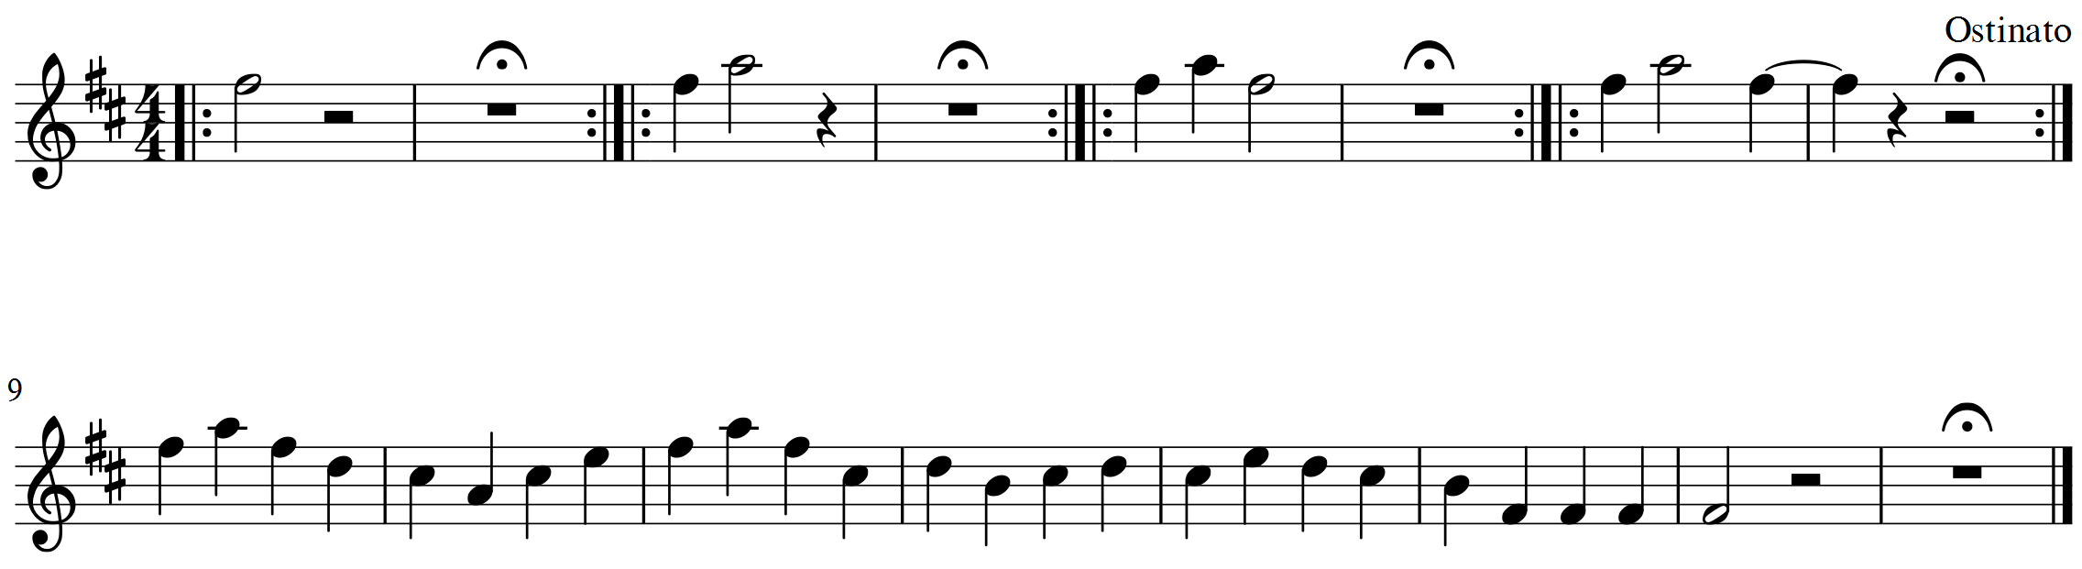

Hearing voices is set of 5 small musical themes composed to 'streamline' interaction and improvisation with the JAM-application.

The 'melody' of the first 4 themes is derived from the intonation of most natural languages: a signal, a question, a request and a demand. The fifth theme is a full 'sentence' with an answer, explanation, refusal, excuse etc. The improvisation can be slow and contemplative of fast and chaotic. 'Disturbing' results can be part of the narrative ... 'hearing voices' is also a synonym for 'auditory hallucination', a feature of some psychiatric illnesses.

The whole piece can be repeated, but this isn't required. The performer can add free improvisation.

Some tips:
- You can test the application on a laptop with headphones (to avoid feedback).
- For 'real' use you need a good microphone.
- Click on the load-button and try out some of the stored settings.
- Download the Jazzperiments-Jam-Kit-zip every now and then, because the application is improved on a regular basis.

Support

jazzperiments@gmail.com or for urgent questions 00 32 475 416885.

